**Project Management Board**

The project management was carried out using Jira software using an agile environment.

Link to my project management board: <https://lharrold.atlassian.net/secure/RapidBoard.jspa?rapidView=2&projectKey=PPW&view=reporting&chart=sprintRetrospective&sprint=2>

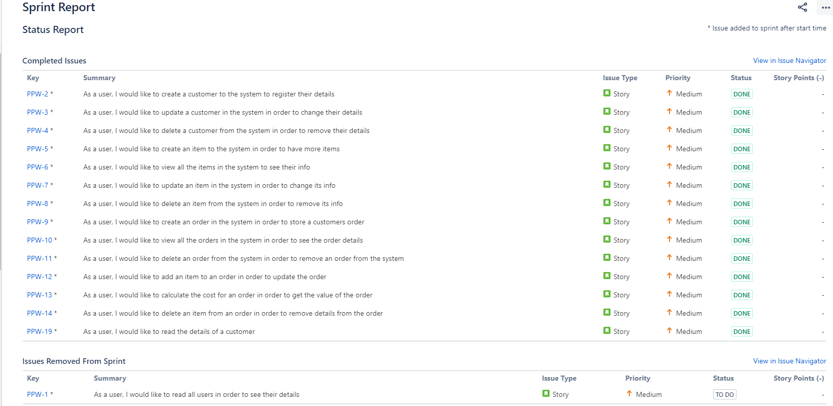Below is a screenshot of all of the user stories that I needed to complete for this project.

I removed the user stories involving the user section of the project as they were part of the extension tasks which I did not complete in the end as I was focused on ensuring the functionality of the minimum specification.